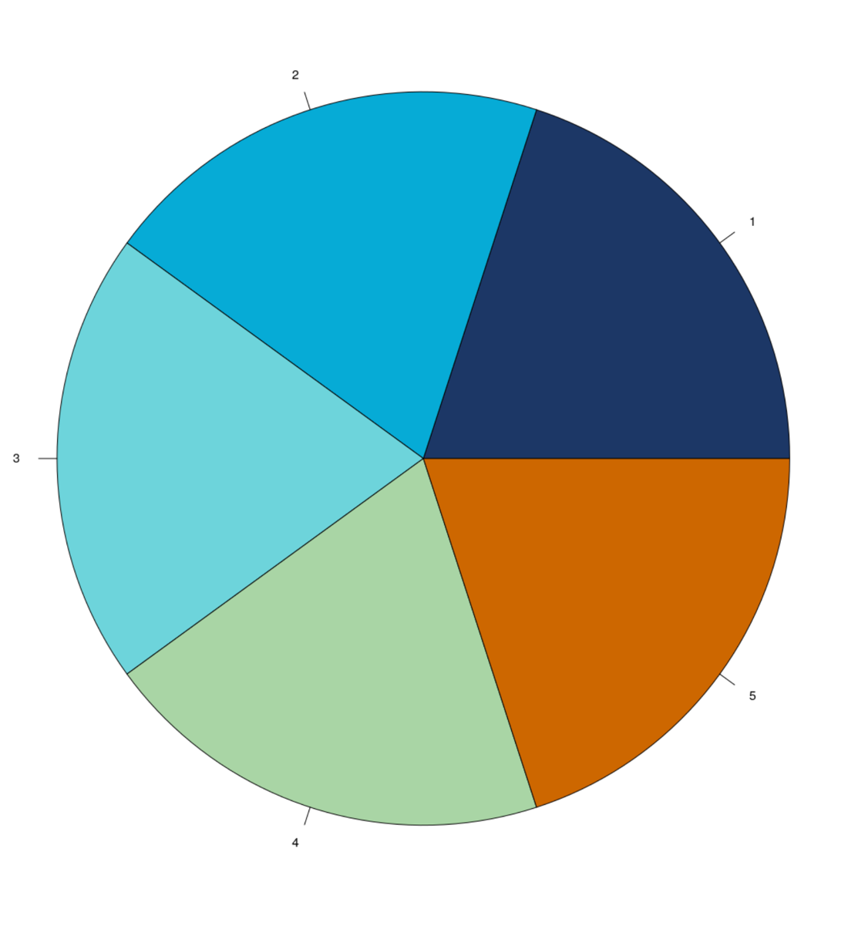
DSPG.palette<-c("#1b3766","#02abd6","#6dd4db","#a9d5a5","#cd6600")

